DETECTING GENETIC DIVERSITY OF BNYVV AND QUANTIFYING INCIDENCE OF RHIZOMANIA IN FIELDS PLANTED TO RESISTANT VARIETIES

Charlie Rush, Rodolfo Acosta-Leal, and David Jones
Texas Agriculture Experiment Station, Amarillo, 79109

Beet necrotic yellow vein virus (BNYVV), which causes rhizomania of sugar beet, causes major reductions in root yield and quality wherever it occurs. When the pathogen is first introduced into a field, yield losses may be minimal. However, in subsequent crops, root yield and quality are both significantly reduced. In the United States, the disease was first identified in California in 1984, but now it occurs in every major sugar beet production region in the country. Fortunately, strong genetic resistance, conferred by the Rz1 gene, was identified soon after rhizomania was identified in the United States, and it has been incorporated into regionally adapted cultivars that allow profitable sugar beet production in fields infested with the pathogen. However, in the Imperial Valley of California in 2002, plants in a field planted to a rhizomania resistant cultivar began to express symptoms of rhizomania. Severe rhizomania has also occurred in Minnesota sugar beet fields planted to rhizomania tolerant cultivars. In Minnesota, the occurrence of rhizomania in disease tolerant cultivars was primarily restricted to individual plants. However, in 2004 and 2005 discrete spots of diseased plants appeared and this essentially ruled out “seed issues” as the cause for disease development. Therefore, inoculum density of viruliferous P. betae, soil edaphic factors, or a new resistance-breaking strain of BNYVV is likely the reason for disease development in rhizomania resistant cultivars. It is important to determine how extensive breakdown of rhizomania resistance is in the United States, whether the etiology of rhizomania in fields planted to rhizomania tolerant cultivars is the same in different production regions, and to devise strategies for managing the problem. One of the goals of our research on rhizomania is to investigate the cause and incidence of rhizomania in fields planted to disease tolerant cultivars. In order to meet this goal, we conducted studies in 2005 with the following objectives: 1) Detect and map genetic variation among resistance-breaking isolates of BNYVV, and 2) Quantify the incidence of rhizomania in fields planted to disease tolerant cultivars and estimate yield loss.

Methods

Objective 1. Detect and map genetic variation among resistance-breaking isolates of BNYVV. Sugar beet plants exhibiting typical, diagnostic symptoms of rhizomania were collected from fields planted to rhizomania tolerant cultivars in California and Minnesota. Since the Rz1 gene only confers tolerance to BNYVV and does not prevent infection of the root, asymptomatic beets were also collected from the same fields where resistance was breaking down in hopes of obtaining wild type, non resistance-breaking isolates of BNYVV. Symptomatic and asymptomatic plants were taken to the TAES plant pathology lab in Amarillo and total RNA was extracted from all plants. Extracted RNA was used to generate cDNA, which in turn was used as template for PCR amplification. Specific primers for RNA 3, the RNA species which has been associated with symptom expression and disease severity, were used to amplify the entire P25 ORF on RNA 3. DNA bands of the expected size were generated. The DNA bands were excised from the electrophoresis gel and these were gel purified and sent off for sequencing. Sequence data was analyzed using a variety of DNA analysis software programs.

Objective 2. Quantify the incidence of rhizomania in fields planted to disease tolerant cultivars and estimate yield loss. In the 2005 growing season, three fields south of Crookston, MN and seven fields south of Willmar, MN were selected for study. These fields were selected because they were planted with rhizomania tolerant cultivars and exhibited a high incidence of blinkers, and spots of diseased plants, throughout all or part of the field. Within each field, five areas were sampled. Each sampling area was geo-referenced and stand counts were made on ten feet of row. Blinkers were counted on the stand count row and the five adjacent rows. Approximately 15 blinkers and 15 healthy sugar beet plants were collected from the general area but outside the counted rows. The sugar beets were rated for rhizomania severity on a scale from 0-4, with 0 as healthy and 4 as severely diseased. The individual blinker and healthy plants were bulked separately at each location. This gave a total of five paired samples for each field. Each sample was processed at the factory for sucrose content and root yield. Beet necrotic yellow vein virus (BNYVV) was assayed by enzyme-linked immunosorbent assay (ELISA) on feeder root tissue of the taproot.
A white tarp, measuring 1’ X by 10’, was placed at each sample location so that it could be identified in aerial photography (Fig. 2). Immediately after the fields were sampled on the ground, digital images were acquired at an altitude of approximately 1700’ mean sea level (800’ above ground) using fixed wing aircraft. The images were acquired with an Olympus 765 UZ digital camera. The nominal field of view of the camera was 43° by 38°. This resulted in an area of about 8 acres with 1.05’ resolution. Images were geo-rectified using ArcView version 9.1 (ESRI, Redlands, CA). The G/B ratio was calculated for each pixel in the image using ENVI version 4.1 (RSI, Boulder, CO) (Fig.3A). Pixels were classified using unsupervised classification with three classes that represented healthy beets, diseased beets and background (soil) (Fig. 3B). The area and percent of each class was calculated for each image.

Results and Discussion

Results of the study on genetic variability among isolates of BNYVV are shown in Table 1 and Figure 1. In greenhouse studies, resistance-breaking isolates of BNYVV from California were highly virulent on cultivars that contained the Rz1 gene, and virus titers were high in infected plants. Wild type isolates from the same fields were not able to replicate well in rhizomania tolerant cultivars and virus titers were significantly lower than those achieved by the resistance-breaking isolates (data not shown). Sequence analysis of the RNA 3 P25 ORF from the different isolates of BNYVV revealed a high degree of nucleotide sequence homology. However, amino acid analysis revealed differences between California wild type isolates and resistance-breaking isolates of BNYVV. The resistance-breaking isolates from California were also genetically distinguishable from isolates of BNYVV obtained from blinkers in Minnesota (Table 1). Amino acids 67,68, and 135 from the P25 RNA3 ORF can be used to distinguish the California resistance-breaking isolates of BNYVV from all other isolates but it is uncertain whether the V₆₇L₆₈E₁₃₅ motif associated with the resistance-breaking isolates is actually responsible for the ability of these isolates to overcome Rz1. The fact that the amino acid motif of isolates from blinkers in Minnesota differs from the California resistance-breaking isolates suggests that the two are genetically distinguishable and that perhaps mechanisms of virulence are different. However, additional tests need to be performed to verify this hypothesis.

Table 1. Amino acid substitutions in the Beet necrotic yellow vein virus P25
protein, associated with resistant breaking isolates and blinkers from
California and Minnesota, respectively.
Source | Isolate^{y} | Amino acid^{z}
Source | Isolate^{y} | 67 | 68 | 135
California | Ch* | V | L | E
 | Mag* | V | L | E
 | DWe* | V | L | E
 | Spr* | V | L | E
 | Tam* | V | L | E
 | Salinas 2005 | A | C | D
 | Wt CIV2005 | A | L | D
Minnesota | Blinker 83* | V | C | D
 | Crookston* | A | H | D
 | Willmar* | A | C | D
 | Glendon 1* | A | C | D
 | Climax* | A | C | D
 | Wt15 2000 | A | C | D

^{x} Blinker is the term used to describe an individual sugar beet infected by Beet necrotic yellow vein virus (BNYVV), which exhibits the florescent yellow foliage typically associated with rhizomania, surrounded by symptomatic beets with dark green foliage.

^{y} Isolates followed by an asterisk “*” represent resistance-breaking CIV-BNYVV from California,
or BNYVV isolates recovered from blinkers in Minnesota. Salinas 2005 and Wt CIV 2005 represent
wild type, non-resistance breaking isolates from Salinas, CA and the Imperial Valley, respectively.
Wt15 2000 is a wild type isolate from Minnesota.

^{z} The V₆₇L₆₈E₁₃₅ signature was consistently found in resistance-breaking CIV-BNYVV populations
during 2005. Asymptomatic plants from the Imperial Valley are infected by genetically heterogeneous
virus populations where A₆₇L₆₈D₁₃₅ is the predominant signature. The A₆₇C₆₈D₁₃₅ signature
frequently has been found in many virus populations collected outside of the Imperial Valley, both from
symptomatic and asymptomatic plants.

________________________________________________________________________
Figure 1. Phylogram generated from nucleotide sequence from the RNA3 P 25 ORF of BNYVV. Resistance –
breaking isolates of BNYVV from California clearly cluster together and are distantly separated from wild type
isolates of BNYVV and isolates obtained from blinkers in Minnesota.

Although isolates of BNYVV obtained from blinkers in Minnesota were genetically different from resistance-breaking strains from California, they were obviously highly virulent and caused significant reductions in root yield and sucrose content (Table 2). Mean root weight of blinkers was reduced approximately 62% compared with asymptomatic, healthy beets growing adjacent to the blinkers. Blinkers also had reduced sucrose content that averaged 1.8 percentage points lower than the healthy beets.

Table 2. Disease rating and yield data from ground truthed plots_______________
Symptom Disease Rating^{y} Mean Root Wt.(lbs) Sucrose (%)______
Healthy 1.7 1.3 14.6
Blinker^{x} 2.5 ___ 0.5 12.8__________
^{x} Blinker is the term used to describe an individual sugar beet infected by BNYVV,
which exhibits the florescent yellow foliage typically associated with rhizomania,
surrounded by healthy beets with dark green foliage.

^{y} Severity of rhizomania was based on a 0 – 4 scale, where 0 = healthy disease
free roots and 4 = severe stunting, root constriction, and massive root proliferation.

When attempting to quantify the incidence of blinkers in the field and whether they were randomly distributed or aggregated, aerial photography was absolutely necessary. From ground level, blinkers often appeared to be randomly distributed but from the air, it was clear that they were clumped into irregular spots, identical to those that appeared when rhizomania first appeared in Minnesota in fields planted to rhizomania susceptible lines.
For aerial photography, the white tarps placed next to the ground truth data collection points were clearly visible from the air (Fig. 2). These allowed the photographer to identify the areas where the ground truth data had been collected and to focus aerial images on those positions in the field. The use of the digital camera to obtain remote images of the diseased spots in the field was highly effective and image analysis was effective in differentiating healthy from diseased plants (Fig. 3) Estimates of percent area of fields affected by rhizomania ranged from 12% to 70%. However, percent area affected did not correlate well with final yield from the sampled fields. For instance, the field with an estimated 12 symptomatic plants yielded 27.2 tons and 15.8% sucrose, while another field in Southern Minnesota with 28% symptomatic plants yielded30.5 tons and 16.2 sucrose (Table 3). It is not uncommon for root yield and sucrose content to be impacted by a number of variable and that partially accounts for this discrepancy. However, it is recognized that our estimates of disease were high when compared to actual ground truth determinations. Larger ground truth plots and better analytical techniques will help resolve this issue.
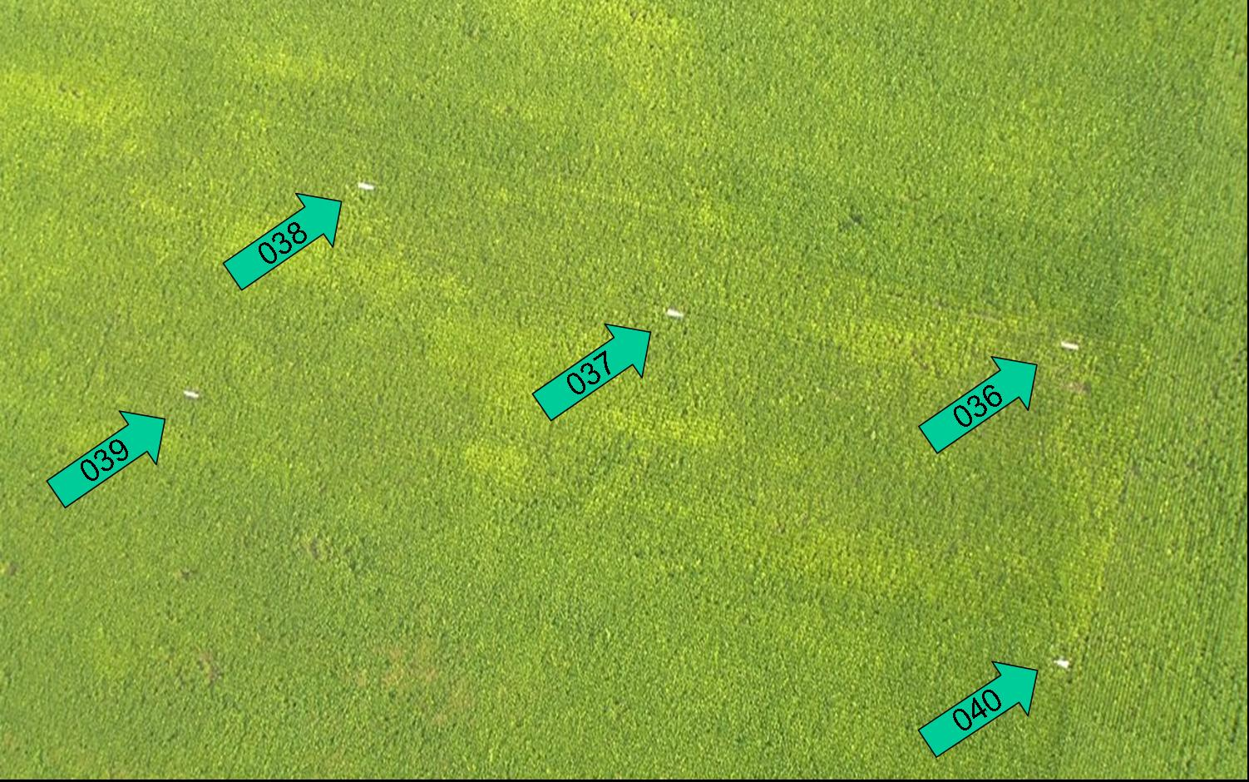

Figure 2. Aerial image of sugar beet field. White tarps mark areas where
ground truth data was taken, and large yellow irregular spots of rhizomania
are easily identified.

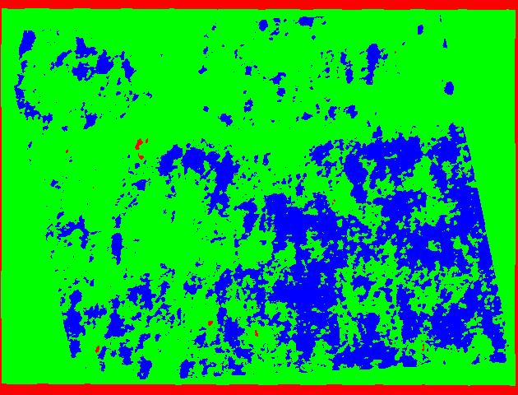
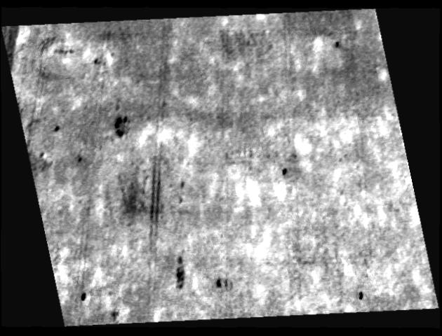
B
A

Figure 3. (A) Aerial image processed in ENVI using the blue / green ratio. (B) Aerial image that has been classified using unsupervised classification with three classes.

Table 3. Ground truth and image data from northern and southern Minnesota, 2005._____________________________
 |  | Avg Field Yield |  |  | Yield Reduction
Field | Location | Sucrose | Tons | % Blinker* | Sucrose (% points) | Root Yield %
1 | Northern | 17.3 | 18.3 | 59 | 2.4 | 67
2 | Northern | 17.0 | 18.8 | 54 | 1.8 | 62
3 | Northern | 17.3 | 18.4 | 70 | 1.9 | 64
4 | Southern | 15.0 | 21.0 | 21 | 1.9 | 69
5 | Southern | 15.8 | 22.8 | 19 | 1.8 | 60
6 | Southern | 15.8 | 27.2 | 12 | 1.7 | 47
7 | Southern | 15.4 | 26.7 | 35 | 1.3 | 50
8 | Southern | 16.2 | 30.5 | 28 | 2.0 | 50
9 | Southern | 16.0 | 23.3 | 31 | 1.6 | 54
10 | Southern | 15.6 | 26.1 | 39 | 1.4 | 56
* data obtained from aerial images using unsupervised classification.

