2006 SUGARBEET ROOT MAGGOT Population Forecast

Mark A. Boetel, Assistant Professor
Robert J. Dregseth, Research Specialist
Allen J. Schroeder, Research Specialist

Department of Entomology, North Dakota State University, Fargo, ND

This forecast is based on sticky-stake monitoring of sugarbeet root maggot (SBRM) fly activity and root damage ratings conducted in grower fields in 2005. Although some areas in the extreme northern Red River Valley underwent a slight decline, several areas of high risk remain for 2006 (Fig. 1). The highest infestations will occur within 12 miles along either side of a north/south line running from just south of Cavalier in northern Pembina Co., ND to Forest River in southern Walsh Co. Moderate infestations are expected within an 8-mile radius outside of the high-risk zone. Other areas where moderate root maggot infestations are likely include: from just north of Cavalier to the Canadian border; fields near Hensel and Crystal; the extreme north central portion of Grand Forks Co.; and also the Casselton/Amenia area of central Cass Co. Low infestations are expected for the rest of the production area, including all fields in western Minnesota.
Proximity of sugarbeets to previous-year beet fields, especially those where insecticide performance was unsatisfactory, increases the risk of having damaging population levels. Weather conditions during the growing season can affect the precision of this forecast, and infestations can vary significantly among fields. Growers in areas at risk from SBRM injury should continue using insecticides at planting time to protect their fields, and pay close attention to fly activity levels during the first 2 to 3 weeks of June to determine whether postemergence insecticide applications will be needed. Producers are also encouraged to review research findings published in recent volumes of “Research and Extension Reports” and the current “Sugarbeet Production Guide” to design effective insect management programs. NDSU Extension will continue to inform growers regarding SBRM activity each spring via radio reports, the NDSU “Crop & Pest Report,” and by notifying sugar cooperative agricultural staff.
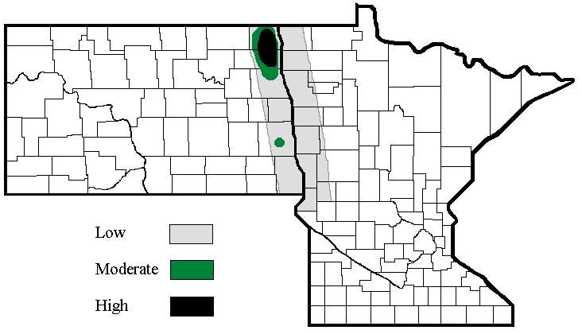

Fig. 1. SBRM population levels anticipated for the Red River Valley during the 2006 growing season.

